POLICY FOR THE USE OF PLASMA-LYTE 148 IN PATIENTS ADMITTED TO
INTENSIVE CARE UNIT AND THEATRES AT NOBLES HOSPITAL

Author(s) | Jessica Yuan (Specialist Pharmacist- Critical Care and Surgery)  Craig Rore (Specialist Pharmacist- Medicines Information)
Version Number | 1
Document effective from | July 2023
Next review due | July 2024
Intended audience | All intensive care unit clinical staff, all theatres clinical staff, all pharmacy clinical staff
Superseded documents | N/A
Stakeholders consulted prior to ratification | Dr Sivakumar Balasubramanian  Dr Peter Faber
Ratified by | IMOG | Date
Previous reviews | N/A
Changes made during latest review | N/A

Contents
1 Introduction 2
2 Purpose 2
3 Scope 2
4 Guideline 2
4.1 Resuscitation 3
4.2 Maintenance 4
4.3 Posology 4
4.3.1 Adults 4
4.3.2 Geriatric Patients 4
4.3.3 Administration rate 4
4.4 Method of administration 4
4.4.1 Preparation for administration 4
4.5 Contraindications 5
4.5.1 Absolute contraindication 5
4.5.2 Relative contraindications 5
4.6 Cautions 6
4.7 Adverse effects 7
4.8 Monitoring 7
4.9 Compatibility 8
4.10 Other information 8
5. References 8
6 Appendices 8

1 Introduction

This protocol provides a clinical guideline for the use of Plasma-Lyte 148 in patients admitted to intensive care unit (ICU) and theatres at Nobles Hospital.

Plasma-Lyte 148 is a balanced, crystalloid intravenous fluid. It is an isotonic solution of electrolytes with concentrations that are designed to match those of plasma. There is increasing evidence that administering excess chloride may have detrimental effect on renal function, even at low doses. Therefore, the use of balanced crystalloids is more favourable in order to avoid fluid induced metabolic acidosis and hyperchloraemia.

2 Purpose

This guideline outlines the indications, administration, contraindications of Plasma-Lyte 148.

This document aims to aid clinicians in offering best care and advice in treating patients, supported by national policy. Clinical judgement in the initiation, review, escalation and de-escalation of patients should be supported where possible by multidisciplinary team assessment.

3 Scope

This document applies to all clinical staff on ICU, theatres and pharmacy working for Manx Care.

4 Guideline

The pharmacological properties of Plasma-Lyte 148 solution are those of its components (water, sodium, potassium, magnesium, chloride, acetate and gluconate). The main effect of Plasma-Lyte 148 is the expansion of the extracellular compartment including both the interstitial fluid and the intravascular fluid.

Fluid balance, serum electrolytes and acid-base balance should be monitored before and during administration, with particular attention to serum sodium in patients with increased non-osmotic vasopressin release (syndrome of inappropriate antidiuretic hormone secretion, SIADH) and in patients co-medicated with vasopressin agonist drugs, due to the risk of hospital acquired hyponatraemia. Monitoring of serum sodium is particularly important for hypotonic fluids.

Studies show that when compared with Plasma-Lyte 148, 0.9% sodium chloride caused a higher rate of metabolic acidosis and hyperchloraemia, leading to decreased renal artery blood velocity, decreased renal cortical tissue perfusion, decreased urine output and increased extravascular fluid accumulation. Instead, a balanced crystalloid with lower chloride concentration is preferred. See appendix 1 for the composition of Plasma-Lyte 148 VS Sodium Chloride 0.9% and Compound sodium lactate (Hartmann’s).

4.1 Resuscitation

The following flowchart highlights the fluid resuscitation procedure:

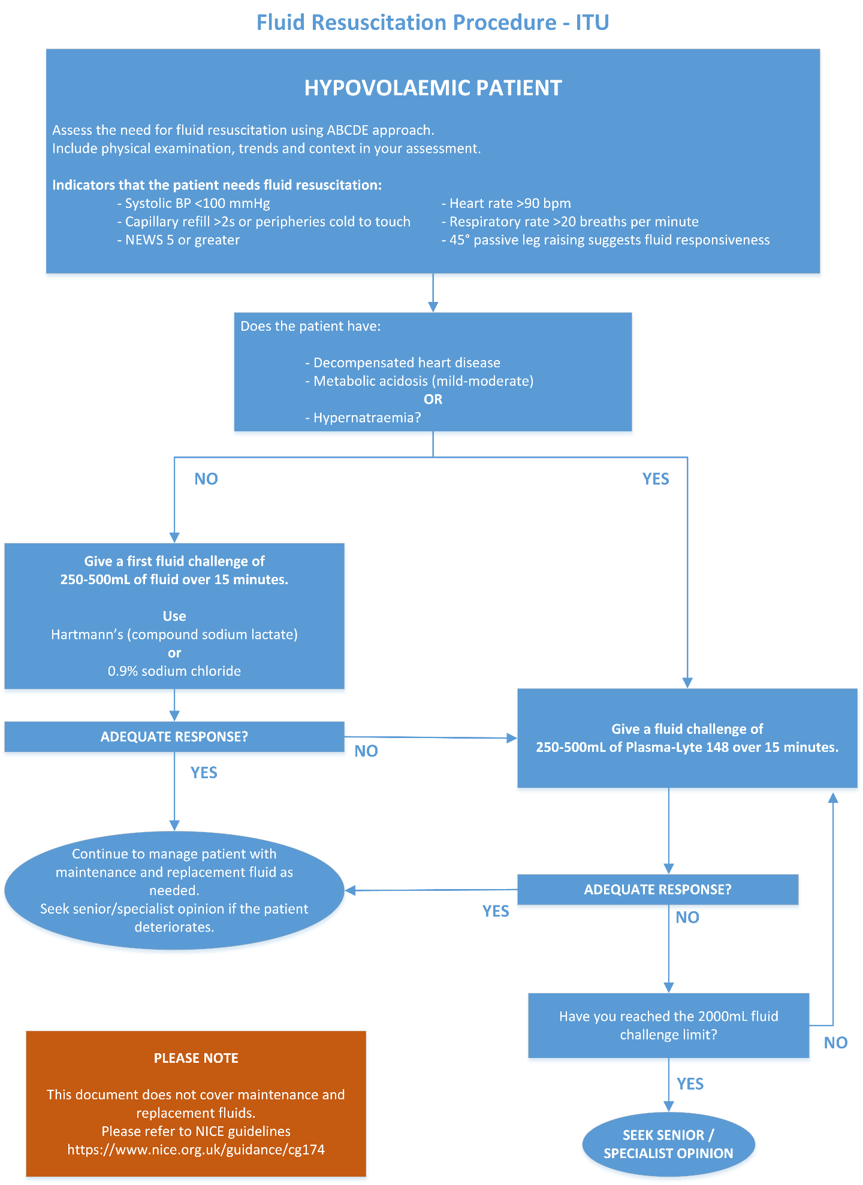

4.2 Maintenance

The use of Plasma-Lyte as maintenance fluid is suitable for patients:

- After receiving over 2000mL of Hartmann’s or 0.9% Sodium Chloride
- With hypernatraemia

For routine maintenance fluids, please refer to nice guidelines: https://www.nice.org.uk/guidance/cg174

The use of Plasma-Lyte 148 is restricted to ICU and theatres only, until further discussion and review.

4.3 Posology

4.3.1 Adults

Plasma-Lyte 148 solution has a tonicity of approximately 295 mOsm/l. The infusion rate and volume depend on the age, weight, clinical condition (e.g. burns, surgery, head-injury, infections), and concomitant therapy should be determined by the consulting physician experienced in intravenous fluid therapy.

4.3.2 Geriatric Patients

When selecting the type of infusion solution and the volume/rate of infusion for a geriatric patient, consider that geriatric patients are generally more likely to have cardiac, renal, hepatic, and other diseases or concomitant drug therapy.

4.3.3 Administration rate

The infusion rate is usually 40 mL/kg/24hr in adults. When used for intraoperative fluid replacement, normal rate can be higher and is about 15 mL/kg/h.

4.4 Method of administration

The administration is performed by intravenous route, due to its iso-osmolality, this solution can be administered through a peripheral vein.

This solution can be administered before, during or after a blood transfusion.

4.4.1 Preparation for administration

The solution should be administered with sterile equipment using an aseptic technique. The equipment should be primed with the solution in order to prevent air entering the system.

The solution should be inspected visually for particulate matter and discoloration prior to administration whenever solution and container permit. Do not administer unless the solution is clear and the seal is intact.

Do not remove unit from overwrap until ready for use. The inner bag maintains the sterility of the solution. Administer immediately following the insertion of infusion set.

Do not use plastic containers in series connections. Such use could result in air embolism due to residual air being drawn from the primary container before the administration of the fluid from the secondary container is completed. Pressurising intravenous solutions contained in flexible plastics containers to increase flow rates can result in air embolism if the residual air in the container is not fully evacuated prior to administration.

Use of a vented intravenous administration set with the vent in the open position could result in air embolism. Vented intravenous administration sets with the vent in the open position should not be used with flexible plastic containers.

Additives may be introduced before infusion or during infusion through the injection site.

4.5 Contraindications

4.5.1 Absolute contraindication

Hypersensitivity to the active substances and excipients

4.5.2 Relative contraindications

- Hyperkalaemia
- Renal failure
- Heart block
- Metabolic or respiratory alkalosis
- Hypochlorhydria

4.6 Cautions

The use of Plasma-Lyte 148 is cautioned in the following groups of patients:

Use in Patients with or at Risk for and from Hypermagnaesemia | Parenteral magnesium salts should be used with caution in less severe degrees of renal impairment and in patients with myasthenia gravis. Patients should be monitored for clinical signs of excess magnesium, particularly when being treated for eclampsia.
Use in patients with Hypocalcaemia | Plasma-Lyte 148 contains no calcium, and an increase in plasma pH due to its alkalinising effect may lower the concentration of ionised (not protein-bound) calcium. Plasma-Lyte 148 should be administered with particular caution to patients with hypocalcaemia.
Use in Patients with or at Risk for Hyperkalaemia | Solutions containing potassium salts should be administered with caution to patients with cardiac disease or conditions predisposing to hyperkalaemia such as renal or adrenocortical insufficiency, acute dehydration, or extensive tissue destruction as occurs with severe burns. The plasma potassium level of the patient should be particularly closely monitored in patients at risk of hyperkalaemia.
Use in patients with potassium deficiency | Although Plasma-Lyte 148 solution has a potassium concentration similar to the concentration in plasma, it is insufficient to produce a useful effect in case of severe potassium deficiency and therefore it should not be used for this purpose.
Risk of Fluid and/or Solute Overload and Electrolyte Disturbances | The patient's clinical status and laboratory parameters (fluid balance, blood and urine electrolytes as well as acid-base balance) must be monitored during use of this solution.  Depending on the volume and rate of infusion, intravenous administration of Plasma-Lyte 148 can cause fluid and/or solute overload resulting in overhydration/ hypervolaemia therefore high volume infusion must be used under specific monitoring in patients with cardiac, pulmonary or renal failure.  High volume infusion must be used under specific monitoring in patients with cardiac or pulmonary failure and in patients with non-osmotic vasopressin release (including SIADH), due to the risk of hospital-acquired hyponatraemia.
Hyponatraemia | Patients with non-osmotic vasopressin release (e.g. in acute illness, pain, post-operative stress, infections, burns, and CNS diseases), patients with heart-, liver- and kidney diseases and patients exposed to vasopressin agonists are at particular risk of acute hyponatraemia upon infusion of hypotonic fluids.  Acute hyponatraemia can lead to acute hyponatraemic encephalopathy (cerebral oedema) characterised by headache, nausea, seizures, lethargy and vomiting. Patients with cerebral oedema are at particular risk of severe, irreversible and life-threatening brain injury.  Children, women in the fertile age and patients with reduced cerebral compliance (e.g. meningitis, intracranial bleeding, cerebral contusion and brain oedema) are at particular risk of the severe and life-threatening brain swelling caused by acute hyponatraemia.
Use in Patients with Hypervolaemia or Overhydration, or Conditions that Cause Sodium Retention and Oedema | Plasma-Lyte 148 should be administered with particular caution to hypervolaemic or overhydrated patients.  Solutions containing sodium chloride should be carefully administered to patients with hypertension, heart failure, peripheral or pulmonary oedema, impaired renal function, pre-eclampsia, aldosteronism, or other conditions associated with sodium retention.
Use in Patients with Severe Renal Impairment | Plasma-Lyte 148 should be administered with particular caution to patients with severe renal impairment. In such patients administration of Plasma-Lyte 148 may result in sodium and/or potassium or magnesium retention.
Use in Patients with or at Risk for Alkalosis | Plasma-Lyte 148 should be administered with particular caution to patients with alkalosis or at risk for alkalosis. Excess administration of Plasma-Lyte 148 can result in metabolic alkalosis because of the presence of acetate and gluconate ions.

4.7 Adverse effects

The infusion must be stopped immediately if any signs or symptoms of a suspected hypersensitivity reaction develop. Appropriate therapeutic countermeasures must be instituted as clinically indicated.

Plasma-Lyte 148 may also cause hypervolaemia, hospital acquired hyponatraemia, acute hyponatraemic encephalopathy, seizures, thrombophlebitis, venous thrombosis, urticaria, infusion site reactions.

Administration in the postoperative period shortly after recovery from neuromuscular block should be used with caution since magnesium salts can lead to recurarisation effect.

4.8 Monitoring

Monitor the patient's clinical status and laboratory parameters (fluid balance, blood and urine electrolytes, and acid-base balance).

4.9 Compatibility

There are limited published data on compatibility with other medicines or infusion fluids. Due to limited data on compatibility, Plasma-Lyte 148 is not to be used to make up/ give medications unless in exceptional circumstances.
Plasma-Lyte 148 is compatible with blood and can be administered before, during or after a blood transfusion.

4.10 Other information

Plasma-Lyte 148 is not indicated for the treatment of hypochloraemic hypokalaemic alkalosis.

Plasma-Lyte 148 is not indicated for the primary treatment of severe metabolic acidosis neither for the treatment of hypomagnesaemia.

5. References

- Summaries of Product Characteristics (2019) Plasma-Lyte 148 (pH 7.4) solution for infusion, Plasma-lyte 148 (ph 7.4) solution for infusion - summary of product characteristics (SmPC) - (EMC). Available at: https://www.medicines.org.uk/emc/product/1795/smpc#gref (Accessed: 19 October 2023).
- Medusa NHS Injectable Medicines Guide (2023) Plasma-Lyte 148 (in water), Medusa NHS Injectable Medicines Guide. Available at: https://www.medusaimg.nhs.uk/IVGuideDisplay.asp (Accessed: 19 October 2023).
- Weinberg, L. et al. (2016) ‘Plasma-lyte 148: A clinical review’, World Journal of Critical Care Medicine, 5(4), p. 235. doi:10.5492/wjccm.v5.i4.235. Available at: https://www.ncbi.nlm.nih.gov/pmc/articles/PMC5109922/ (Accessed: 19 October 2023).

6 Appendices

Appendix 1: Composition of Plasma-Lyte 148 VS Sodium Chloride 0.9% and Compound sodium lactate

 | Sodium (mmol/L) | Chloride (mmol/L) | Potassium (mmol/L) | Magnesium (mmol/L) | Calcium (mmol/L) | Acetate (mmol/L) | Gluconate (mmol/L) | Lactate (mmol/L) | Malate (mmol/L) | eSID (mEq/L) | Theoretical osmolarity (mOsmol/kg) | Actual osmolality (mOsmol/kg) | pH
Plasma | 135-145 | 95-105 | 3.5-5.3 | 0.8-1.2 | 2.2-2.6 | Nil | Nil | Nil | Nil | 42 | 291 | 287 | 7.35-7.45
Sodium chloride (0.9%) | 154 | 154 | Nil | Nil | Nil | Nil | Nil | Nil | Nil | 0 | 308 | 286 | 4.5-7
Compound sodium Lactate | 131 | 111 | 5 | Nil | 2 | Nil | Nil | 29 | Nil | 29 | 278 | 278 | 5-7
Plasma-Lyte 148 | 140 | 98 | 5 | 1.5 | Nil | 27 | 23 | Nil | Nil | 50 | 295 | 271 | Approx. 7.4

